1. Osama bin Laden’s son urges Syrian mujahideen to unite in Palestine (10.5.16)

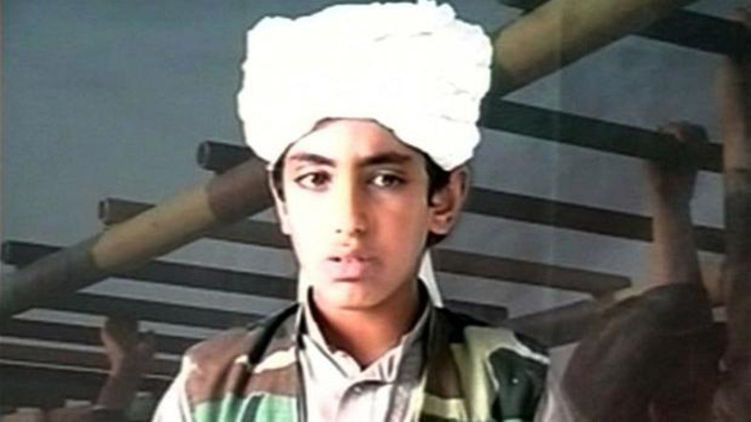 Source: Al-Arabiya

The son of Osama bin Laden urged mujahideen to unite to “Free Palestine”. Hamza bin Laden, the favorite son of Osama, who had been grooming him to take over as al-Qaida’s leader, said “The road to liberating Palestine is today much shorter compared to before the blessed Syrian revolution”. His undated message comes after al Qaida’s leader, Ayman al-Zawahiri, urged mujahideen in Syria to unite, despite his continued rejection of Islamic State and its proclaimed caliphate.

2. New settlements in East Jerusalem (9.5.2016)

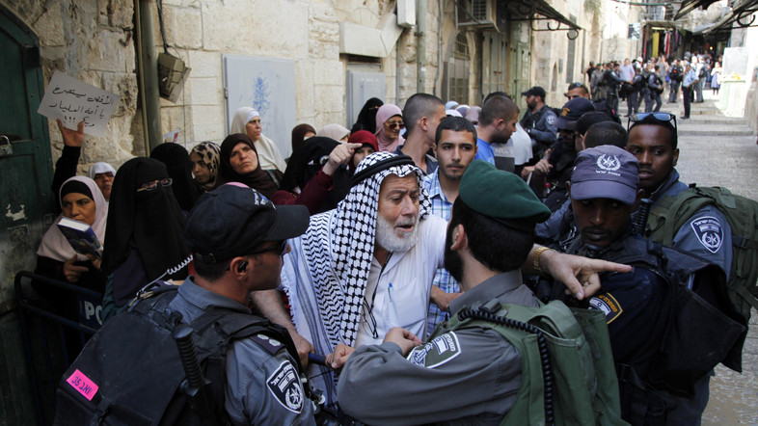 Source: Al-Arabiya

Israeli settler group takes over Muslim quarter building in Jerusalem. The three-story building, which is owned by Palestinian residents, is situated only 300 meters from Al-Aqsa Mosque. Israeli forces have since cordoned off the area and prevented Arab residents of the neighborhood from entering the building. Palestinians accuse Israel of waging an aggressive campaign to “Judaize” Jerusalem (Al-Quds) with the aim of effacing its Arab and Islamic identity and eventually expelling its Palestinian inhabitants

3. Israeli PM stated that Israel will not hesitate to strike Gaza (8.5.16)

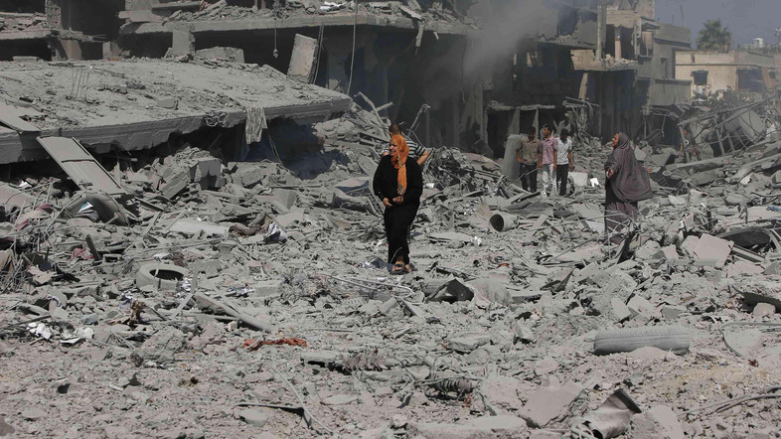 Source: Al-Arabiya

Netanyahu said that they will not hesitate to strike the Gaza Strip in the attempt to eliminate Hamas. The PM stated that they do not wish any escalation whatsoever, but they will also not “be deterred from doing what it required to maintain security” and press hunt for Gaza tunnels.

4. Palestinian girl and her brother killed at checkpoint (8.5.2016)

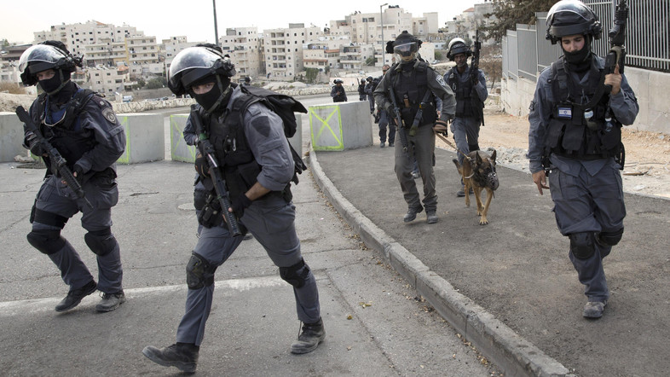 Source: Al-Arabiya

A young girl and her brother were shot dead at a busy checkpoint in the West Bank. According to Israeli police, the two Palestinians were believed to bare knives upon them. Israeli police stated that the two were approaching the police officers, while the officers were warning them to stop. Shortly after the incident, Israeli security forces released photographs with the knives they said were used in the attempted assault.

5. Israeli warplanes pound Gaza Strip, injure four (5.5.2016)

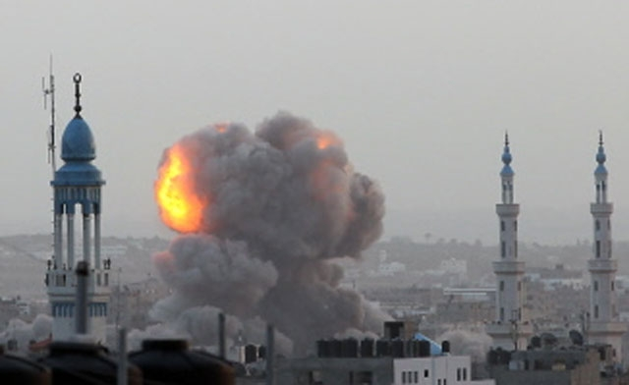 Source: Al-Arabiya
At least four people have been injured in Israeli airstrikes against the Gaza Strip in recent attacks against the blockaded coastal territory. Palestinian sources said the first airstrike struck a metal workshop in the southeastern Zeitoun neighborhood of Gaza City on Thursday morning, injuring a 65-year-old man, Ma’an news agency reported. Three other children also sustained injuries after being hit by flying debris in the targeted area. The second aerial attack targeted a site belonging to the Palestinian resistance movement of Hamas in the city of Beit Lahia, completely destroying the building and sending a massive plume of smoke into the air above the area. Israeli military aircraft also struck Mount Sourani, which lies east of Gaza City.

6. IAF strikes targets near the Gaza Strip (5.5.16)

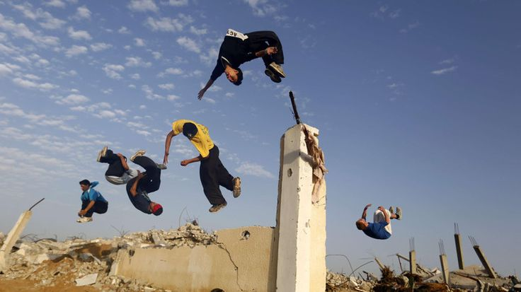 Source: Al-Arabiya

Israeli Air Force warplanes hit Hamas targets in Gaza. There were no immediate reports of injuries. According to Hamas’ statements, Israel bore “full responsibility” for the escalation in hostilities. The IAF struck five times around Gaza’s derelict international airport, in response to mortar fire from Hamas at IDF troops on the border, as the army said in a statement. The interior ministry for the Hamas-run Strip stated that there was no cause of casualties in the nearby areas.

7. A Palestinian woman was killed by Israeli tank shelling (6.5.16)

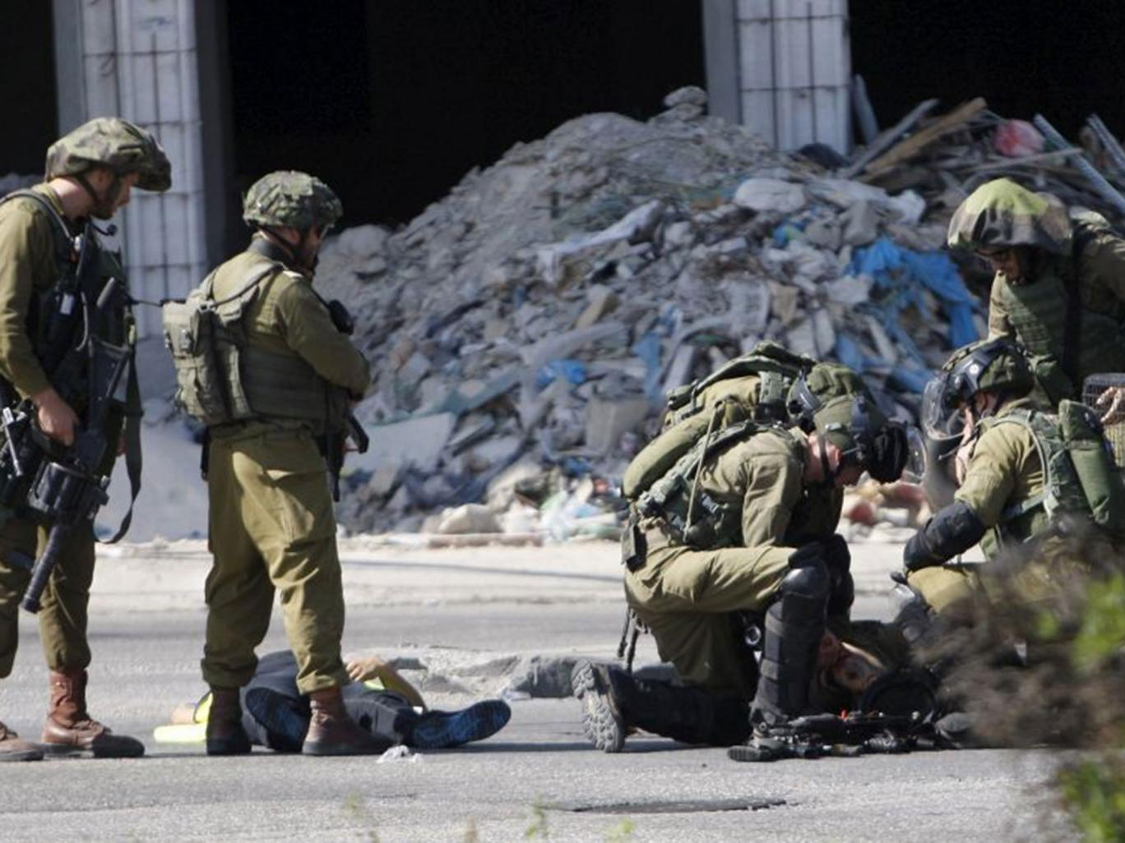 Source: Al-Arabiya

The 54-year-old Palestinian woman was killed by Israeli tank shelling near Rafah, as stated by Health officials in Gaza. The Israeli tanks released firebombing attacks in return to the Palestinian attack in Gaza, targeting Israeli officers. The al-Qassam, Brigades- the military wing of the Hamas operation- denounced the Israeli incursions, describing it a breach of 2014 cease-fire.
8. Donald Trump: Israel settlement construction should keep going! (4.5.2016)

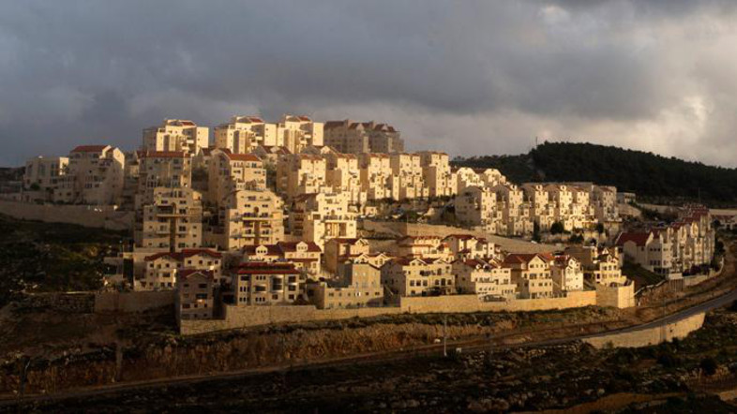 Source: Al-Arabiya

Contrary to any sense of respect for human rights, the Republican presidential candidate Donald Trump says Israel should continue construction of illegal settlements across the occupied West Bank. Asked in an interview with the British paper Daily Mail whether there should be a pause in settlement construction in the occupied territories, Trump responded: “No, I don't think there should be a pause.” Trump said the settlement construction must “keep going” and “keep moving forward,” because Palestinians fired “thousands of missiles” at Israel.

Η ομάδα ΒΕΠ: Δρ. Ευάγγελος Ηλίας-Τέμπος (Συντονιστής ΒΕΠ, Μέλος του ΕΠΜΑ), Δρ. Ευάγγελος Βενέτης (Συντονιστής ΕΠΜΑ), Κα. Θεοδώρα Φαμπρικέζη (Επιμελήτρια ΒΕΠ, Μέλος του ΕΠΜΑ). O Δρ. Γεώργιος Τζογόπουλος συμμετέχει ως αρχισυντάκτης της ιστοσελίδας του ΕΛΙΑΜΕΠ .

